Step1: Create a new project

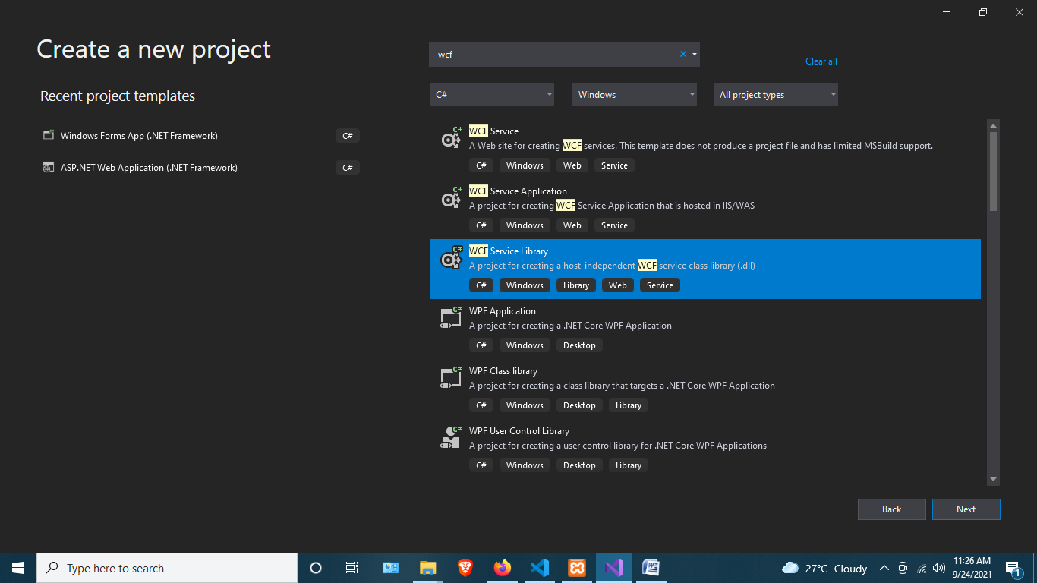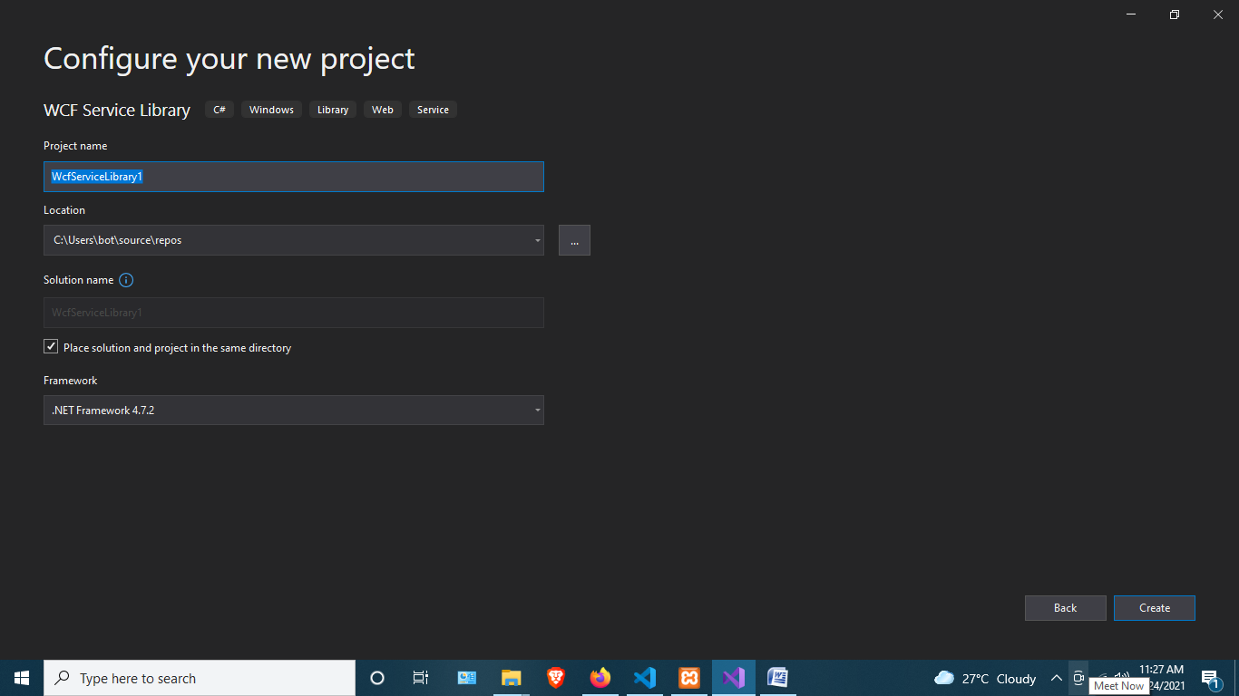

Step 2: Delete app config

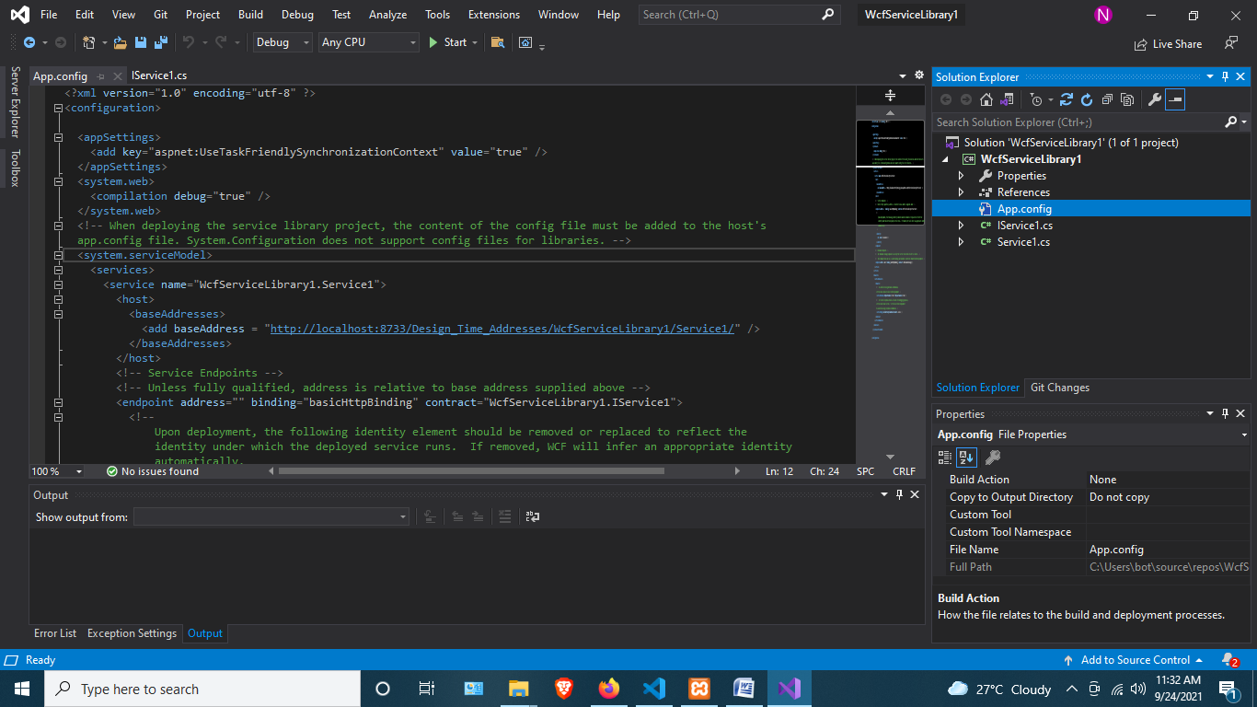

And Paste this code

<?xml version="1.0" encoding="utf-8" ?>

<configuration>

<system.web>

<compilation debug="true"></compilation>

</system.web>

<system.serviceModel>

<behaviors>

<serviceBehaviors>

<behavior name="NewBehavior">

<serviceDebug />

<serviceMetadata />

</behavior>

</serviceBehaviors>

</behaviors>

<services>

<service behaviorConfiguration="NewBehavior" name="WcfServiceLibrary1.Service1">

<endpoint address="" binding="netTcpBinding" bindingConfiguration="" name="tcp"

contract="WcfServiceLibrary1.IService1" />

<endpoint address="mex" binding="mexTcpBinding" bindingConfiguration="" name="mextcp"

contract="IMetadataExchange" />

<host>

<baseAddresses>

<add baseAddress="net.tcp://localhost:8080/SamapleSrc" />

</baseAddresses>

</host>

</service>

</services>

</system.serviceModel>

</configuration>

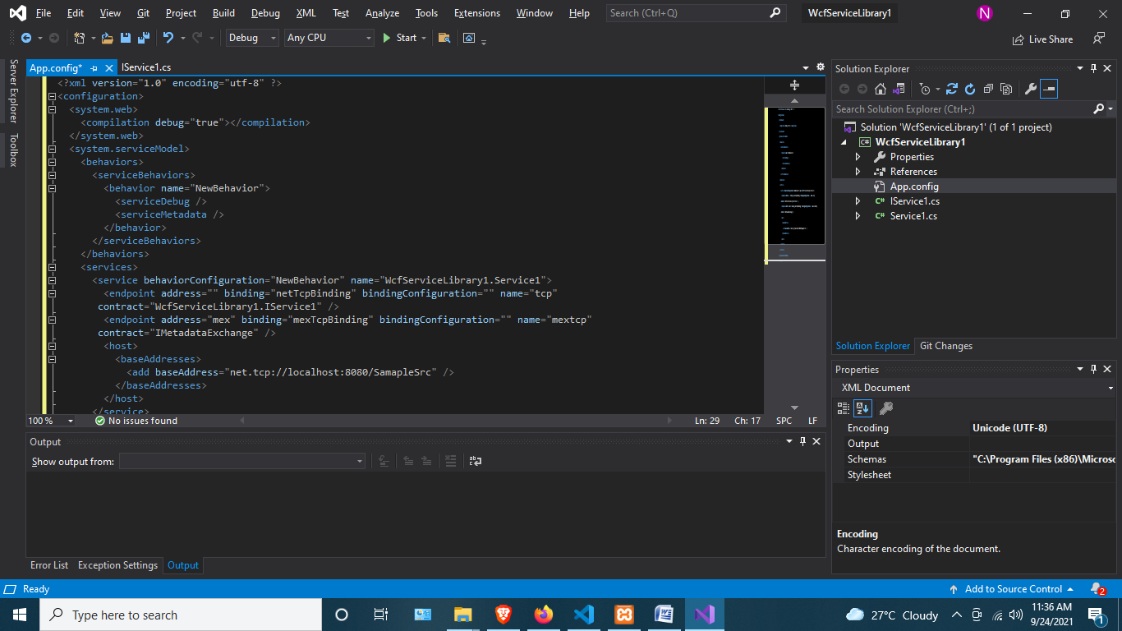

Step 3: Build the project

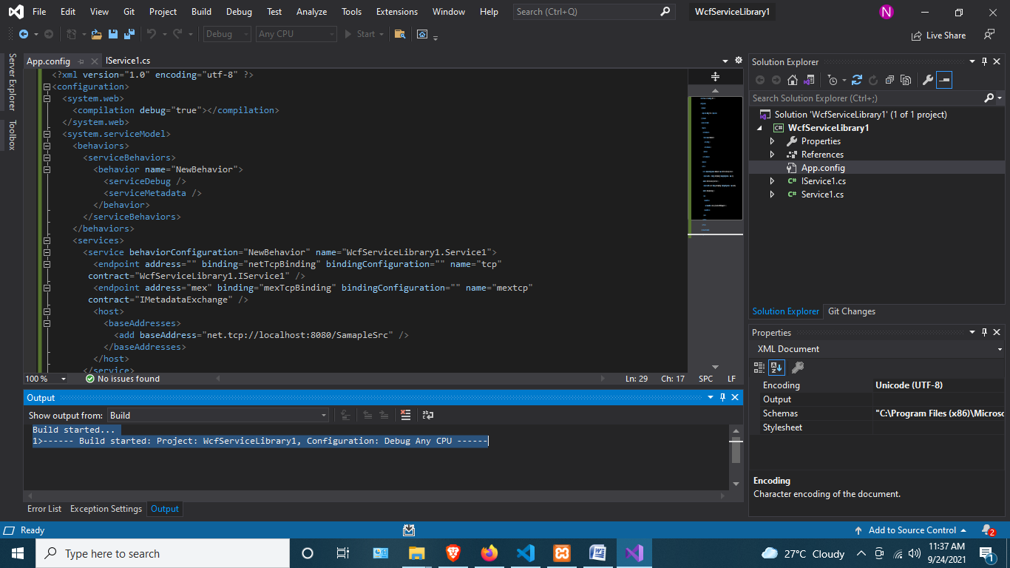

Step 4: Run the project

